**Historical Urban Political Ecology (HUPE)**

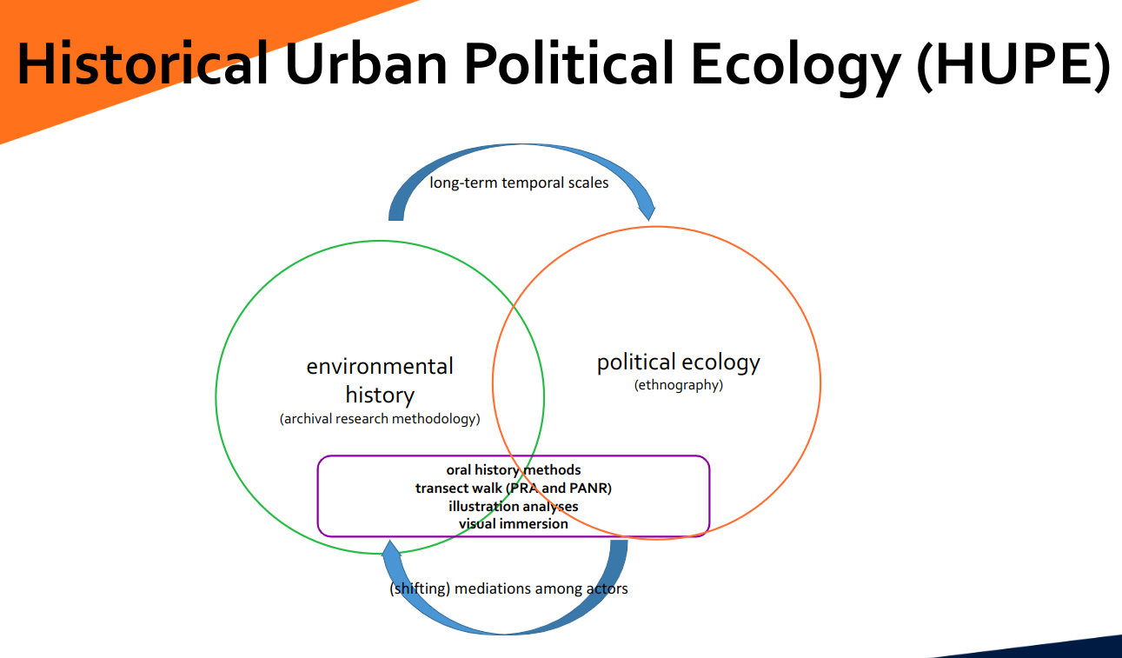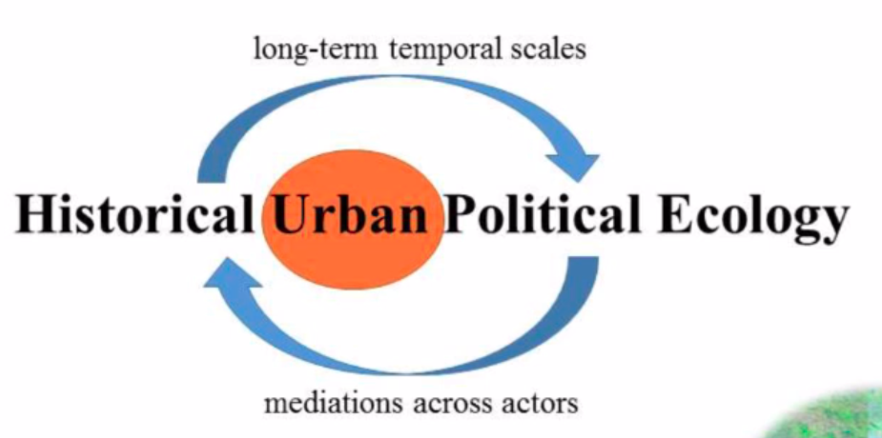

WHAT?

The interdisciplinary field of study:-Relationship between human societies, urban development, natural environment

The intersection of Urban History, Political Ecology, critical geography

Understand how urbanization has affected in the long term to the environment, social relations, and powers.

WHY?

Historical observations help us understand the trends and patterns of the relationship between humans and the economic urban development

Critcal lens to understand political aspect of urban development.

HOW?

Qualitative and quantitative methods. Intersection of many many fields and methods.

**WHAT:**

Historical Urban Political Ecology (HUPE) is an interdisciplinary field of study that examines the relationship between human societies, urban development, and the natural environment over time. It combines elements of urban history, political ecology, and critical geography to explore how processes of urbanization have impacted natural ecosystems, shaped social and political relations within cities, and influenced access to and control over natural resources within urban contexts.

HUPE scholars investigate how power relations and social inequalities have influenced the urban environment and how environmental changes have shaped social and political dynamics in cities. They also analyze how urban development has been influenced by economic, political, and cultural factors and how urbanization has affected the relationship between humans and nature.

Overall, HUPE seeks to offer a critical perspective on urban development that takes into account historical and ecological factors in order to better understand the complex dynamics shaping urban environments and their social and political implications.

**WHY:**

HUPE is an important field of study because it seeks to understand the complex and dynamic relationships between human societies, urbanization, and the natural environment. By examining the historical processes of urban development, HUPE scholars can identify patterns and trends in the relationship between humans and the environment and assess the environmental and social consequences of urbanization.

HUPE also provides a critical lens through which to understand the politics of urban development and the distribution of environmental benefits and harms within cities. By analyzing the power dynamics that shape urban development and environmental policies, HUPE can help identify opportunities for more equitable and sustainable urban futures.

Overall, HUPE is important because it offers a comprehensive and interdisciplinary approach to understanding the complexities of urbanization and environmental change and provides insights that can inform more sustainable and just urban development policies and practices.

**HOW:**

HUPE is a field of study that is interdisciplinary in nature and draws on a range of theoretical and methodological approaches. Scholars in HUPE often use a combination of qualitative and quantitative research methods, including archival research, ethnography, remote sensing, and GIS mapping, to analyze historical and contemporary urban environmental issues.

In terms of theoretical approaches, HUPE draws on concepts and frameworks from urban studies, political ecology, environmental history, and critical geography. HUPE scholars often explore the intersections of power, politics, and ecology in urban contexts, analyzing how social and environmental change are intertwined and how different actors shape urban development and environmental policies.

HUPE also emphasizes the importance of engaging with local communities and stakeholders in the co-production of knowledge, recognizing that environmental issues are often deeply embedded in social, cultural, and political contexts. In this way, HUPE seeks to bridge the gap between academia and practice, and to generate insights that can inform more sustainable and just urban development policies and practices.

**METHOD:**

The process of Historical Urban Political Ecology (HUPE) research involves several key steps:

1. Identifying a research question: HUPE research typically starts with the identification of a research question that is focused on exploring the relationship between urban development, the natural environment, and social and political dynamics in a particular city or region.

“Golden era” & “Sheer Apathy”

1. Collecting data: HUPE scholars often use a range of methods to collect data, including archival research, interviews with key informants, ethnographic fieldwork, and remote sensing and GIS mapping. The type of data collected will depend on the specific research question and the research methods employed.
2. Analyzing data: HUPE scholars use a range of analytical tools and frameworks to analyze their data, including statistical analysis, discourse analysis, and critical theoretical frameworks from political ecology, urban studies, and environmental history.
3. Synthesizing findings: Once the data has been analyzed, HUPE researchers synthesize their findings to identify key patterns and relationships between urban development, the environment, and social and political dynamics. This often involves developing theoretical frameworks to help explain the data and drawing on previous research in the field.
4. Communicating results: Finally, HUPE researchers communicate their findings through academic publications, presentations at conferences and workshops, and engagement with policy makers and stakeholders. HUPE researchers often seek to engage with local communities and stakeholders to ensure that their research is relevant and useful for addressing environmental and social issues in the context of urban development.

**USABILITY:**

The usability of Historical Urban Political Ecology (HUPE) research is significant, as it provides valuable insights into the complex and dynamic relationships between urban development, the natural environment, and social and political dynamics in cities. Some examples of the usability of HUPE research are:

1. Informing urban development policies: HUPE research can provide valuable insights into the environmental and social consequences of urban development policies and help inform the development of more sustainable and equitable urban development policies.
2. Identifying environmental risks and vulnerabilities: HUPE research can help identify environmental risks and vulnerabilities within urban areas, such as exposure to air pollution or vulnerability to flooding, which can inform disaster risk reduction strategies and urban planning efforts.
3. Promoting community engagement: HUPE research can help facilitate community engagement and participation in the development of urban policies and planning efforts, by identifying the social and environmental impacts of urban development and engaging with local communities to ensure their needs and perspectives are taken into account.
4. Advancing academic knowledge: HUPE research can contribute to advancing academic knowledge in the fields of urban studies, political ecology, and environmental history, by developing new theoretical frameworks, providing empirical evidence to support existing theories, and identifying new research questions.
5. Addressing social & economical inequalities:

Overall, HUPE research is highly usable, as it offers a critical perspective on urban development and environmental change that can inform policy and practice in ways that promote more sustainable and just urban futures.

